Information Dialog

Selecting File → Info... invokes the Information Dialog for the currently loaded dataset or from the corresponding toolbar button.

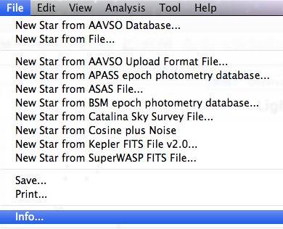
Here is an example Information Dialog for 2 years of R Car data:
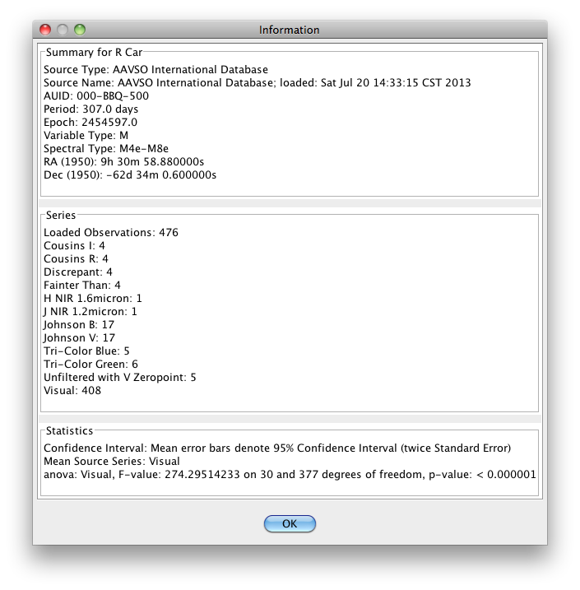
The dialog is divided into Summary, Series, and Statistics sections.

The Summary section includes information about the source of the dataset, AAVSO Unique ID (AUID), and if known, period, epoch, variable type, spectral type, and coordinates. For an AID loaded dataset like this VSX is consulted for such information.

For an observation source other than AID (e.g. AAVSO upload or download files, ASAS, Kepler), VSX is not consulted so the summary information will be different. Here is an example of an Information Dialog for ASAS R Car data:
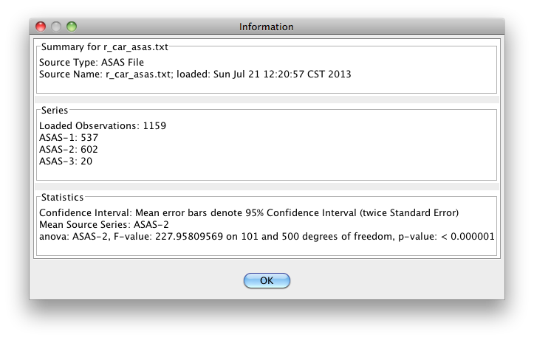
The Series section lists all series present in the dataset (e.g. the filter band or visual observations) along with the number of observations in each series.

The Statistics section provides statistical information including the standard confidence interval of mean error bars, the series that is currently selected to yield the binned mean series, and the ANOVA (analysis of variance) statistic based upon this mean series.

The ANOVA p-value indicates whether there is sufficient evidence to reject the null hypothesis that there is no non-trivial signal (of some kind). A low p-value indicates that the probability of there being no non-trivial signal is low. A high value indicates that the probability of there being no non-trivial signal is high. A low p-value does not mean that there is a high probability of a signal being present. Also, the question of what kind of signal there may be is a separate issue, e.g. it could be, for example, the result of actual variability in the star's brightness, observer bias, or an artifact observation frequency. See the References and Further Reading section (especially Foster (2010)) for more information.

